Experiment No. : 7

Title: N Queen problem using Backtracking

Batch: B3 Roll No.: 16010422230 Experiment No.: 07

Aim: To Implement N Quuen problem using Backtracking. & Virtual Lab on N Queen algorithm using Backtracking

Algorithm of N Queen problem:
1. isSafe() Function:
- This function checks if placing a queen at position (row, col) on the board is safe.
- It checks three conditions:
- No other queen in the same row (horizontal check).
- No other queen in the upper left diagonal.
- No other queen in the lower left diagonal.

2. solveNQueensUtil() Function:
- This function is a recursive helper function that tries to place queens column by column.
- It starts with the leftmost column (col = 0) and recursively tries to place a queen in each row of that column.
- If it finds a safe position, it marks that position on the board and moves to the next column.
- If all queens are placed successfully (col >= N), it returns true.
- If a queen cannot be placed in any row of the current column, it backtracks and tries the next row in the previous column.
- If no safe placement is found for a column, it returns false.

3. solveNQueens() Function:
- This function initializes the chessboard with all cells set to 0 (no queen placed).
- It calls solveNQueensUtil() to solve the N-Queens problem.
- If no solution exists, it prints "Solution does not exist" and returns false.
- If a solution exists, it prints the solution by calling printSolution() and returns true.

4. printSolution() Function:
- This function simply prints the chessboard configuration, with 1 representing a queen and 0 representing an empty cell.

5. Main Function:
- Reads the size of the chessboard (N) from the user.
- Calls solveNQueens() to solve the N-Queens problem for the given board size.

Working of N Queen problem:

Initialize: Create an empty chessboard of size N×N.

PlaceQueens() Function:
This function will be responsible for placing queens on the chessboard.

It takes parameters:
board: The current state of the chessboard.
col: The current column where we want to place the queen.

Base Case:
If col becomes equal to N, then all queens have been successfully placed. Print the solution.
For each row in the current column (col):

Check if it’s safe to place a queen at this position.
A position is safe if no other queen threatens it. That is, there are no other queens in the same
row, column, or diagonal.
If it’s safe, mark this cell as a queen&#39;s position on the board.
Recur to place the remaining queens (col + 1).

Backtrack:
If placing the queen at the current position doesn&#39;t lead to a solution, backtrack by removing the
queen from the current position and try placing it in the next row in the same column.

Main Function:
Initialize an empty board.
Call the PlaceQueens() function with col initially set to 0.

Virtual Lab of N Queen problem:
Simulate Manual steps of N Queen Problem using Backtracking for 5x5 Matrix using following Link and display the Output.

https://vsit.edu.in/vlab/AI/main%20ckt/simulator/4QueenSolution.htm

Time Complexity Derivation of N Queen problem:

The time complexity of the N Queen problem when solved using backtracking is exponential,
typically O(N^N). This is because the algorithm explores all possible configurations of queens
on the board, leading to a large search space. Advanced techniques may offer improvements, but
the problem remains inherently complex due to its combinatorial nature.

Program(s) of N Queen problem:

import java.util.Scanner;
public class NQueens
{
static boolean isSafe(int[][] board, int row, int col, int N)
{
for (int i = 0; i < col; i++)
{
if (board[row][i] == 1)
{
return false;
}
}
for (int i = row, j = col; i >= 0 && j >= 0; i--, j--)
{
if (board[i][j] == 1)
{
return false;
}
}
for (int i = row, j = col; i < N && j >= 0; i++, j--)
{
if (board[i][j] == 1)
{
return false;
}
}

return true;
}

static boolean solveNQueensUtil(int[][] board, int col, int N)
{
if (col >= N)
{
return true;
}
for (int i = 0; i < N; i++)
{
if (isSafe(board, i, col, N))
{
board[i][col] = 1;
if (solveNQueensUtil(board, col + 1, N))
{
return true;
}
board[i][col] = 0;
}
}
return false;
}

static boolean solveNQueens(int N)
{
int[][] board = new int[N][N];

for (int i = 0; i < N; i++)
{
for (int j = 0; j < N; j++)
{
board[i][j] = 0;
}
}

if (!solveNQueensUtil(board, 0, N))
{
System.out.println("Solution does not exist");
return false;
}
printSolution(board);
return true;
}

static void printSolution(int[][] board)
{
for (int i = 0; i < board.length; i++)
{
for (int j = 0; j < board[0].length; j++)
{
System.out.print(board[i][j] + " ");
}
System.out.println();
}
}

public static void main(String[] args)
{
Scanner scanner = new Scanner(System.in);
System.out.print("Enter the size of the chessboard (N): ");
int N = scanner.nextInt();
scanner.close();
solveNQueens(N);
}
}

Output(o) of N Queen problem:

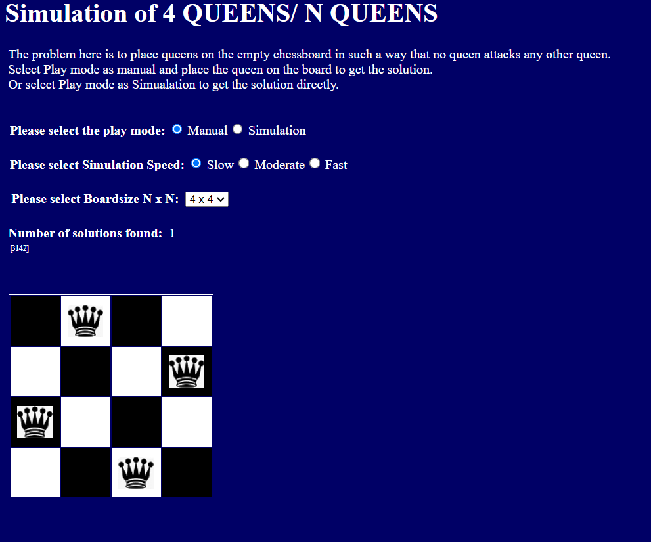

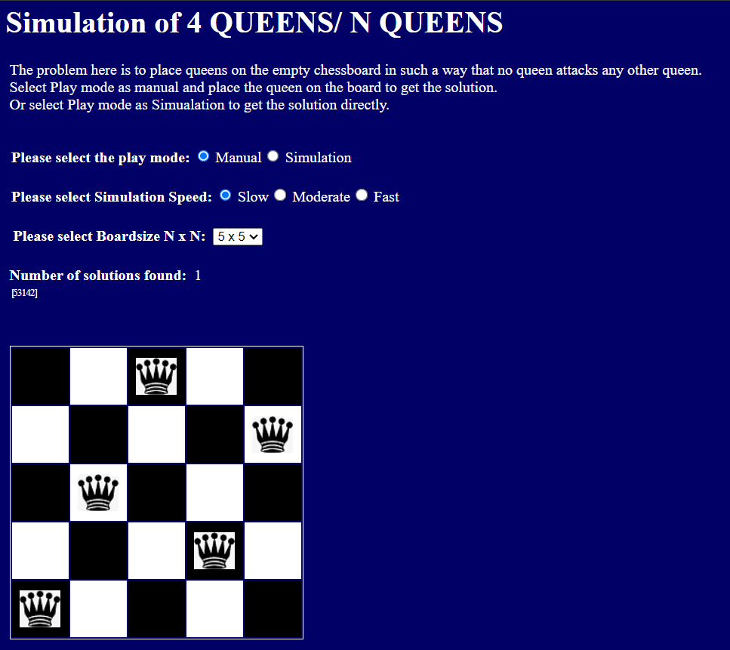

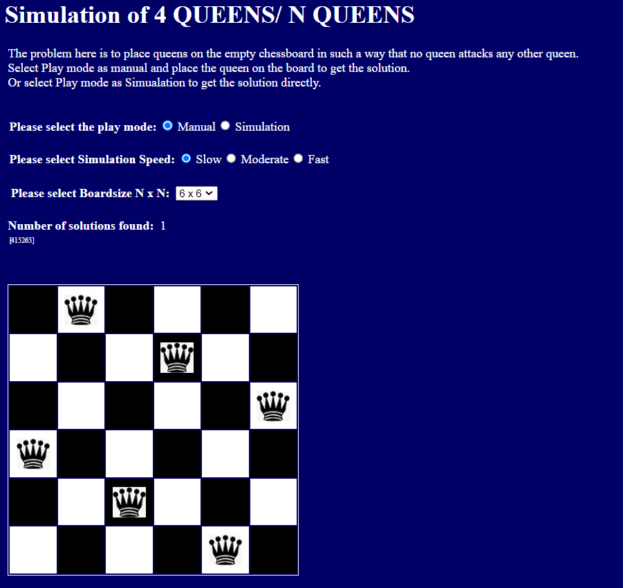

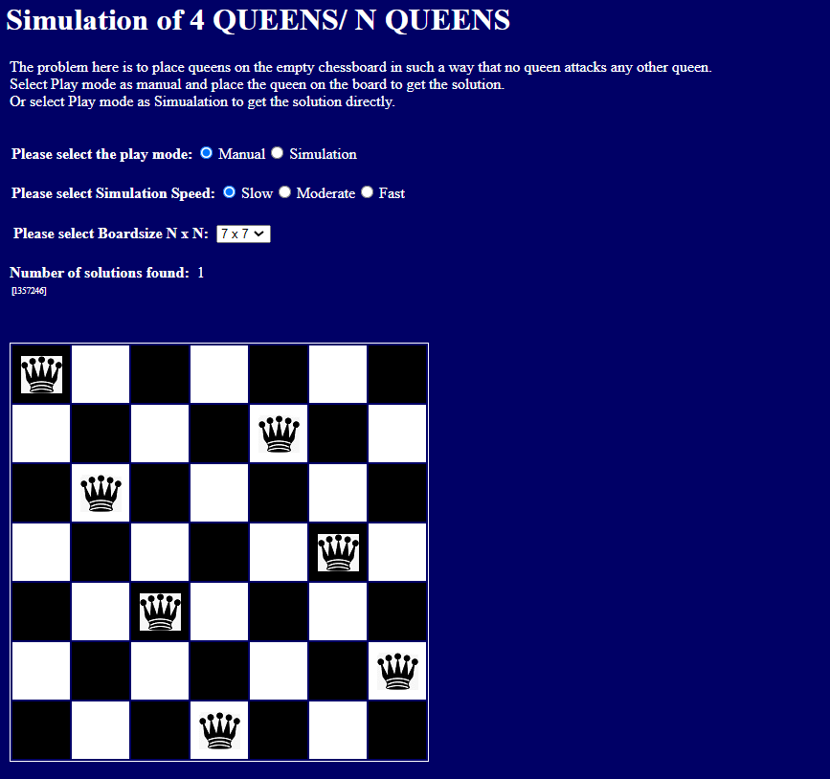

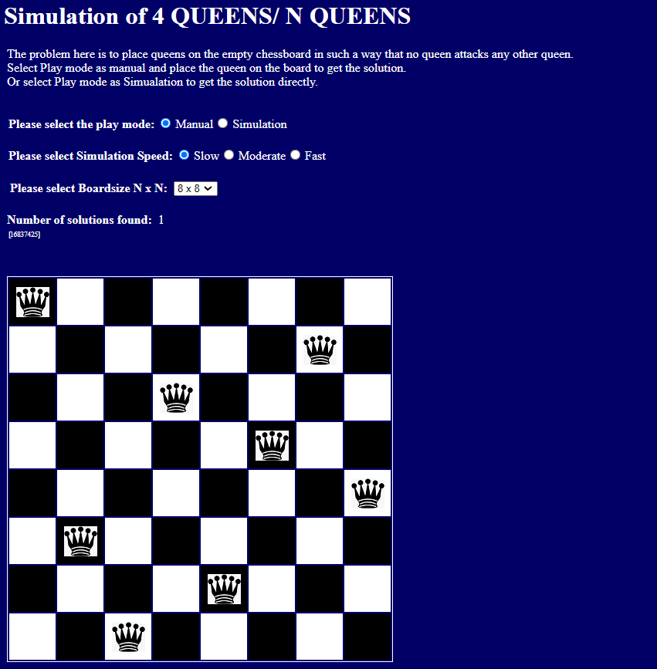

Post Lab Questions:-
Explain the process of backtracking ? What are the advantages of backtracking as against brute force algorithms? What do you mean by P and NP Problem?

Backtracking:
1. Backtracking is an algorithmic technique for solving problems incrementally by making choices and backtracking when needed.
2. It systematically explores all possible solutions while pruning branches that cannot lead to a valid solution.
3. It's particularly useful for problems involving decision-making where each decision depends on previous ones.

Advantages of Backtracking over Brute Force:
1. Pruning: Backtracking intelligently prunes the search space, avoiding exploration of paths that cannot lead to a solution.
2. Efficiency: It can be more efficient as it systematically explores feasible options.
3. Space Efficiency: Requires less memory as it only maintains the current path being explored.

P vs. NP Problem:
1. P (Polynomial Time): Class of problems solvable in polynomial time by a deterministic Turing machine.
2. NP (Nondeterministic Polynomial Time): Class of problems verifiable in polynomial time.
3. P vs. NP asks whether every problem whose solution can be verified in polynomial time can also be solved in polynomial time.
4.Resolution of P vs. NP has profound implications for cryptography, optimization, and various other fields.
5. It remains an open question in computer science with significant implications for computational complexity theory.

Conclusion: (Based on the observations):

We understood the N Queen problem. The manual way to understand its working is way much
easier. Through stimulation we understood how many solutions one chess board can contain
where its 4x4 0r 8x8.

Outcome:
CO3: Implement Backtracking and Branch-and-bound algorithms.

References:
- Richard E. Neapolitan, " Foundation of Algorithms ", 5th Edition 2016, Jones & Bartlett Students Edition
- Harsh Bhasin , " Algorithms : Design & Analysis", 1st Edition 2013, Oxford Higher education, India
- T.H. Coreman ,C.E. Leiserson,R.L. Rivest, and C. Stein, " Introduction to algorithms", 3rd Edition 2009, Prentice Hall India Publication
- Jon Kleinberg, Eva Tardos, " Algorithm Design", 10th Edition 2013, Pearson India Education Services Pvt. Ltd.

